**Lab-06 : Run a multi Pod containers**

**Step 1 :List all the pods**

# kubectl get pods

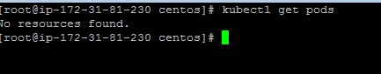

**Step 2 :Edit the configuration files of nginx-multi-label**

# vim replicaset.yaml

**apiVersion**: apps/v1

**kind**: ReplicaSet

**metadata**:

**name**: ajay-replicaset

**spec**:

**replicas**: 3

**selector**:

**matchLabels**:

**app**: prod

**template**:

**metadata**:

**labels**:

**app**: prod

**spec**:

**containers**:

- **name**: ajay

**image**: nginx

resources:

limits:

memory: “100Mi"

cpu: "100m"

requests:

memory: "50Mi"

cpu: "50m"

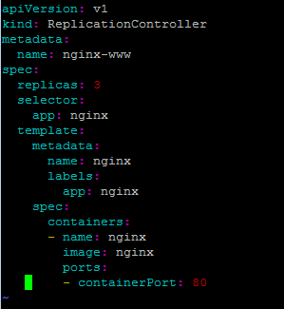

**Step 3 :List all the current running nodes(Now all Minion(Node)are ready for use)**

# kubectl get nodes

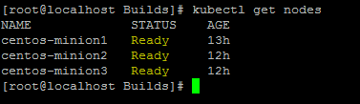

**Step 4 :Now create the nginx-multi-label container**

# kubectl create -f replicaset.yaml

**Step 5:Get the details about replicationcontroller**

# kubectl describe replicaset ajay-replicaset

**Step 6 :List all the current running pods(These 3 are just now created the pod with above configurations)**

# kubectl get pods

**Step 7 : Validate on which node a particual pod is running**

kubectl describe pods ajay-replicaset-46q72

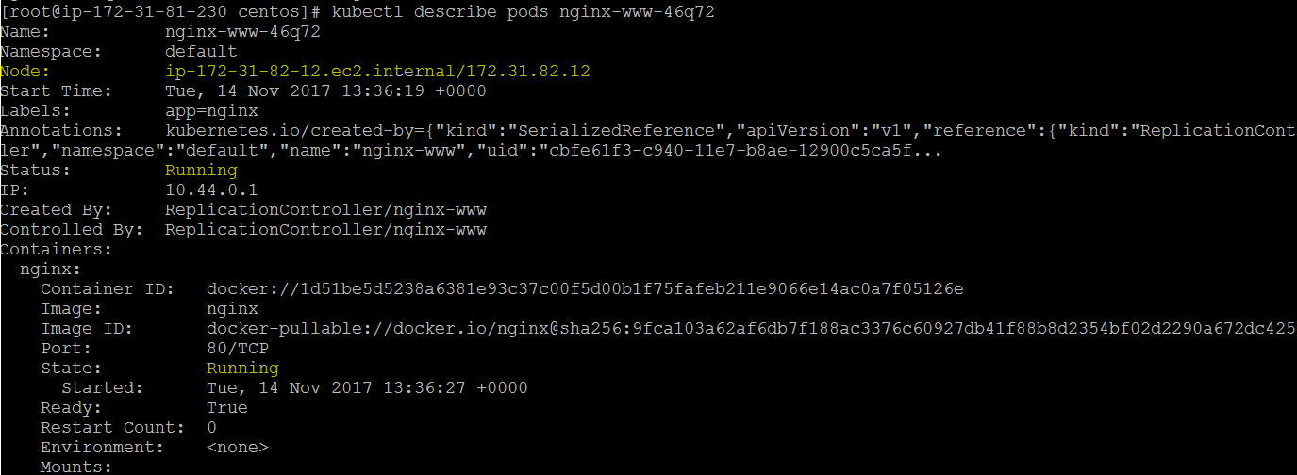

**Step 7 :Now list the running containers(On all the Minion(Node) )**

# docker ps | grep ajay



docker rm -f d61ad0b1438c

docker ps | grep ajay



**kubectl get pods -l app=prod**

**kubectl scale rc nginx-www --replicas=5**